MOORABBIN & DISTRICTS OBEDIENCE DOG TRAINING CLUB INC.
CRITERIA FOR ACKNOWLEDGMENT OF TITLES AND PERPETUAL TROPHIES

TITLE PLAQUES
Members of MODC who have been a member of the Club for at least twelve months and who gain a performance title in any discipline that is either taught at the Club* and/or recognised and approved by ANKC** may apply for a plaque (on receipt of the dog’s first title) and then subsequent tiles for each title gained.
Members need to apply for this by filling out the notification of title form and attaching copies of ALL pass cards relating to the titles gained. This form and copies of pass cards need to be handed in to the MODC office by the last day of training in December. It is the responsibility of the member to ensure
- they are using the current form – dated with the current calendar year.
- the form is correctly filled out with all required information given.
- ALL copies of pass cards relating to the title gained are attached.
It should be noted that if the last pass for a title is awarded before the last training day in December the title tile will have the current year irrespective if the VIC Dogs registration has been updated. This criteria will also be used when determining eligibility for the Club perpetual awards as described below.

PHOTOGRAPHS OF DOGS DISPLAYED IN THE CLUB ROOMS
Members of MODC who have been a member of the Club for at least twelve months and who gain a performance title in any discipline that is either taught at the Club* and/or recognised and approved by ANKC** are entitled to have their dog’s photo displayed in the Club rooms.
Members may apply for this at any time during the year by going to the Club office and
- Providing a 8 x 10 inch photograph of their dog ( portrait orientation) ensuring there is enough room at the bottom of the photo to add the required wording.
- Providing the wording that they want to have on the bottom of the photo – including ALL the ANKC recognised titles that the dog has earned.

RECOGNITION OF CHAMPION DOGS BY MODC
MODC will award Championship Trophies in performance disciplines that are both taught at the Club and recognised by ANKC ie. Obedience, Agility , Rally Obedience and Flyball (FDGCH title) Championship titles.
Members need to apply for this by filling out the notification of title form and attaching a copy of their title certificate from Dogs Victoria. Handlers applying for this recognition need to have been a member of the Club for at least twelve months.

* ANKC recognised performance disciplines are Agility, Dances with Dogs, Draft Test, Endurance, Flyball, Herding, Lure Coursing, Obedience, Tracking, Rally Obedience, Retrieving & Field, Sled Sports
** MODC taught performance disciplines are Agility, Flyball, Obedience and Rally Obedience

PERPETUAL TROPHIES
- Individual sponsored trophies will continue until all replicas are exhausted.

- Champion and Grand Champion titles are not included when awarding perpetual trophies.

- If the last pass for a title is awarded before the last training day of the year these dogs will be eligible for a Club perpetual award in the current year. If the last pass is after the end of club training for the year these dogs will be considered for perpetual awards in the following year.

- Club perpetual awards will be awarded by the MODC committee after consideration of the notification of title forms submitted by the due date.

- To be eligible for a Club perpetual award

  - the dog’s owner must have been a member of the Club for at least twelve months.
  - the dog and owner must have trained regularly at the club for at least twelve months to the satisfaction of the Committee.

- The current Club perpetual awards and their criteria are listed on the following pages.

OBEDIENCE RELATED TROPHIES

MOORABBIN DOG CLUB TROPHY OBEDIENCE
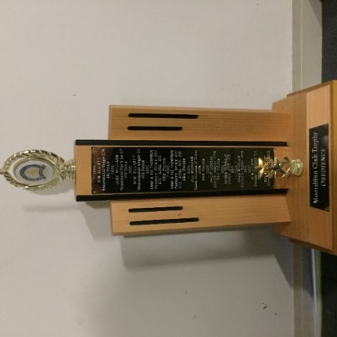
- Club sponsored

Awarded to the Registered or Associate Dog/Bitch with the highest aggregate score (ie the total of the first three qualifying scores) in gaining any obedience title excluding CCD. To be eligible for this award the dog’s owner must have been a member of the Club and the dog and owner must have trained regularly at the club for at least twelve months to the satisfaction of the committee.

AL & MI HEWITT TROPHY
-Club sponsored
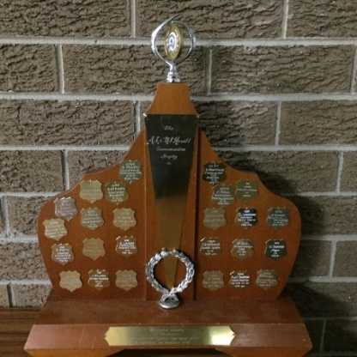
The trophy was originally donated by the late Alf Hewitt and his wife Mavis. Alf and Mavis were foundation members of the club. Alf was the first president and he and Mavis were the club’s first patrons.
Awarded to the Registered or Associate Dog/Bitch with the highest aggregate score (ie the total of the first three qualifying scores) in gaining the Community Companion Dog (CCD) title in the current year.

To be eligible for this award the dog’s owner must have been a member of the Club and the dog and owner must have trained regularly at the club for at least twelve months to the satisfaction of the committee.
THE BORRANEER BROISA PERPETUAL TROPHY
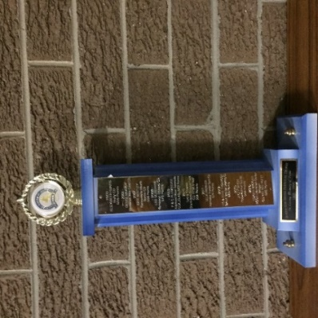
- Sponsored by Cynthia Plumridge

Awarded to the Registered or Associate Dog/Bitch with the highest aggregate score (ie the total of the first three qualifying scores) in gaining the Novice (CD) title in the current year.

To be eligible for this award the dog’s owner must have been a member of the Club and the dog and owner must have trained regularly at the club for at least twelve months to the satisfaction of the committee.

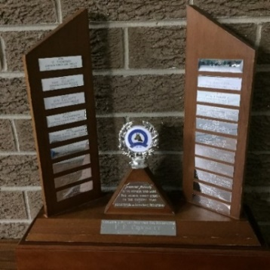
F.E CROCKETT TROPHY
- Sponsored by Philip Jordan and Joanne Bechaz

Frank Crockett was a foundation member, past president, instructor and full panel judge. His ideas are incorporated in the Club’s original constitution. Frank trained at least two dogs to UD standard.

Awarded to the Registered or Associate Dog/Bitch who has obtained one of the following titles in the current year – UD or UDX – with the highest single qualifying score.

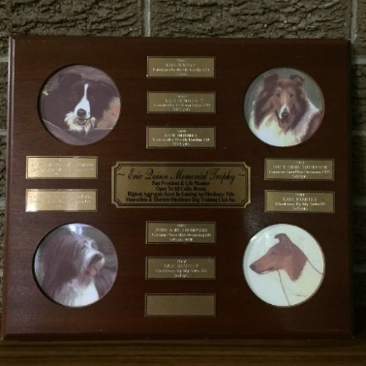
ERIC QUINN MEMORIAL TROPHY

- Sponsored by Mary Quinn in memory of her husband Eric Quinn, past president and life member of the club.

Awarded to any type of Collie (ie Rough, Smooth, Border, Bearded) with the highest aggregate score (ie the total of the first three qualifying scores) in gaining any obedience title in the current year. The qualifying scores are converted to percentages so that all obedience classes can be compared.

To be eligible for this award the dog’s owner must have been a member of the Club and the dog and owner must have trained regularly at the club for at least twelve months to the satisfaction of the committee.

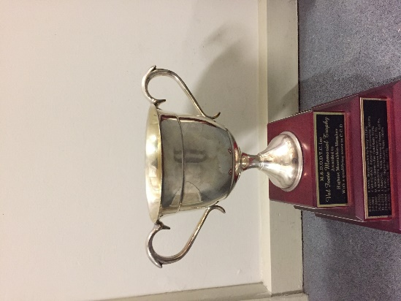

VAL FOOTE TROPHY

Awarded to a Moorabbin member obtaining the highest qualifying score in CCD at the Moorabbin Obedience Dog Trial. This trophy is presented at the Obedience Trial.

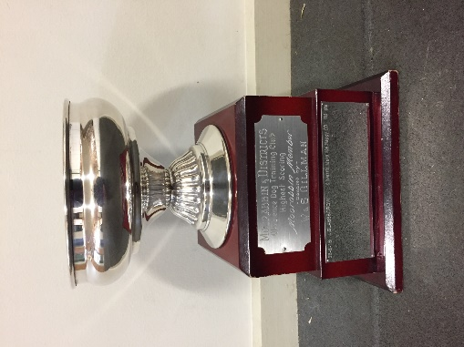
ROSE BOWL TROPHY

Awarded to a Moorabbin member obtaining the highest qualifying score in any obedience class excluding CCD at the Moorabbin Obedience Dog Trial. This trophy is presented at the Obedience Trial.

AGILITY RELATED TROPHIES

MOORABBIN DOG CLUB TROPHY AGILITY
-Club sponsored
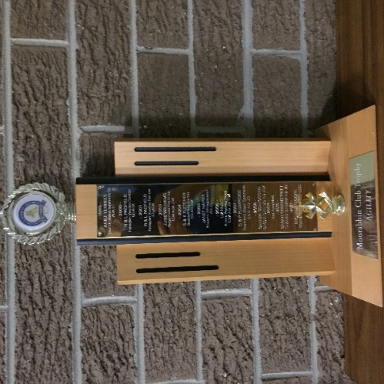

Awarded to the Registered or Associate Dog/Bitch who has obtained any Agility title in the current year with the fastest qualifying time. Individual course times are expressed as a percentage of the standard course time (SCT) for comparison purposes. To be eligible for this award the dog’s owner must have been a member of the Club and the dog and owner must have trained regularly at the club for at least twelve months to the satisfaction of the committee.

MOORABBIN DOG CLUB TROPHY JUMPING
- Club sponsored
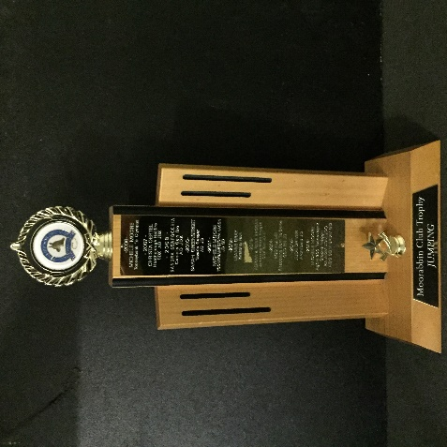

Awarded to the Registered or Associate Dog/Bitch who has obtained any Jumping title in the current year with the fastest qualifying time. Individual course times are expressed as a percentage of the standard course time (SCT) for comparison purposes. To be eligible for this award the dog’s owner must have been a member of the Club and the dog and owner must have trained regularly at the club for at least twelve months to the satisfaction of the committee.

RALLY RELATED TROPHIES

LUCY LOU MEMORIAL RALLY OBEDIENCE TROPHY
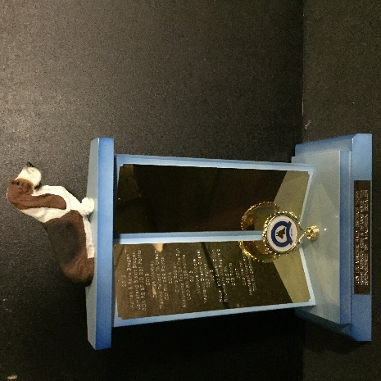
- Sponsored by Maureen Boaler in memory of her beloved Basset Hound, Lucy.

Awarded to the Registered or Associate Dog/Bitch who has obtained the highest aggregate score (ie. The total of the first three qualifying scores) in gaining a Rally Obedience Novice Title in the current year. To be eligible the name of the recipient must be approved by Maureen Boaler.

MOORABBIN DOG CLUB RALLY TROPHY
-Club sponsored
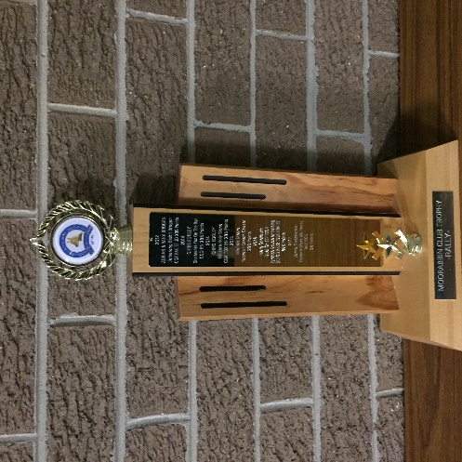
Awarded to the Registered or Associate Dog/Bitch who has obtained the highest individual score in gaining a Rally Title (excluding Rally Novice and Rally Champion) in the current year. If there is a tie, the trophy goes to the dog with the fastest time. If there is still a tie, the trophy goes to the Dog/Bitch with the highest title. To be eligible for this award the dog’s owner must have been a member of the Club and the dog and owner must have trained regularly at the club for at least twelve months to the satisfaction of the committee.

